|  |  |
| --- | --- |
| **Name** | Muhammad Arslan Raza |
| **Section** | A |
| **Roll no.** | 2020-EE-403 |

**Lab 7**

**Experiment no. 6**

**Observe the working principle of Heat Pump**

**Introduction:**

A heat pump is a mechanical system that allows for the transference of [heat](https://en.wikipedia.org/wiki/Heat) from one location (the "source") at a lower temperature to another location (the "sink" or "heat sink") at a higher temperature. Thus a heat pump may be thought of as a "heater" if the objective is to warm the heat sink (as when warming the inside of a home on a cold day), or a "refrigerator" if the objective is to cool the heat source (as in the normal operation of a freezer). In either case, the operating principles are identical. Heat is moved from a cold place to a warm place. The objective of a heat pump, however, is to maintain a heated space at a high temperature. This is accomplished by absorbing heat from a low-temperature source, such as well water or cold outside air in winter, and supplying this heat to the high-temperature medium such as a house.

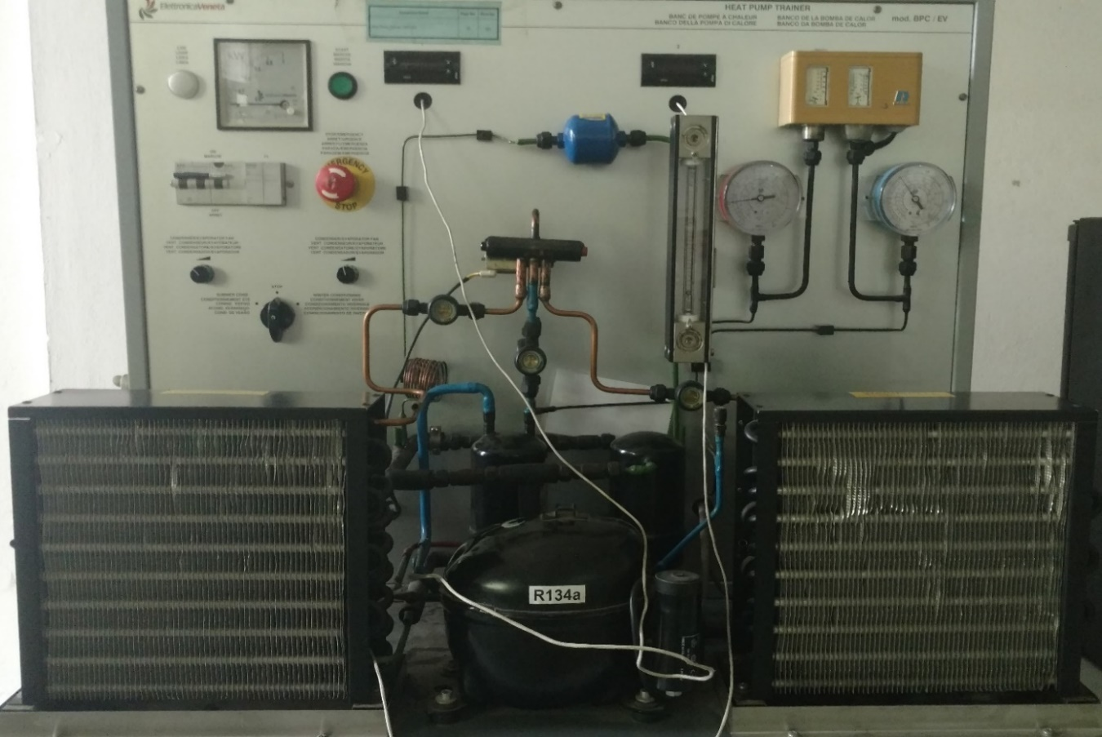

Figure no. 7.1: Model of Heat Pump

**Parts list and details:**

Parts of heat pump is same as refrigerator or an air conditioner.

* Compressor
* Condenser
* Expansion valve/capillary tube
* Evaporator
* Control board
* Accumulator
* Heat strips
* Thermostat

**Control board:**

Controls whether the heat pump system should be in cooling, heating or defrost mode. **Coils:**

**The accumulator:**

A reservoir that adjusts the refrigerant charge depending on seasonal needs.

**Heat strips:**

An electric heat element is used for auxiliary heat. This added component is used to add additional heat on cold days or to recover from lower set back temperatures rapidly.

**Thermostat or control temperature:**

Sets your desired temperature.

**Explanation:**

An [air-source heat pump](http://www.goodmanmfg.com/products/heat-pumps) uses advanced technology and the refrigeration cycle to heat and cool your home. This allows a heat pump to provide year-round indoor comfort – no matter what the season is.

## **Heat Pump in Air Conditioning Mode:**

When properly installed and functioning, a heat pump can help maintain cool, comfortable temperatures while reducing humidity levels inside your home.

1. Warm air from the inside of your house is pulled into ductwork by a motorized fan.
2. A compressor circulates refrigerant between the indoor evaporator and outdoor condensing units.
3. The warm air indoor air then travels to the air handler while refrigerant is pumped from the exterior condenser coil to the interior evaporator coil. The refrigerant absorbs the heat as it passes over the indoor air.
4. This cooled and dehumidified air is then pushed through connecting indoor ducts to air vents throughout the home, lowering the interior temperature.
5. The refrigeration cycle continues again, providing a consistent method to keep you cool.

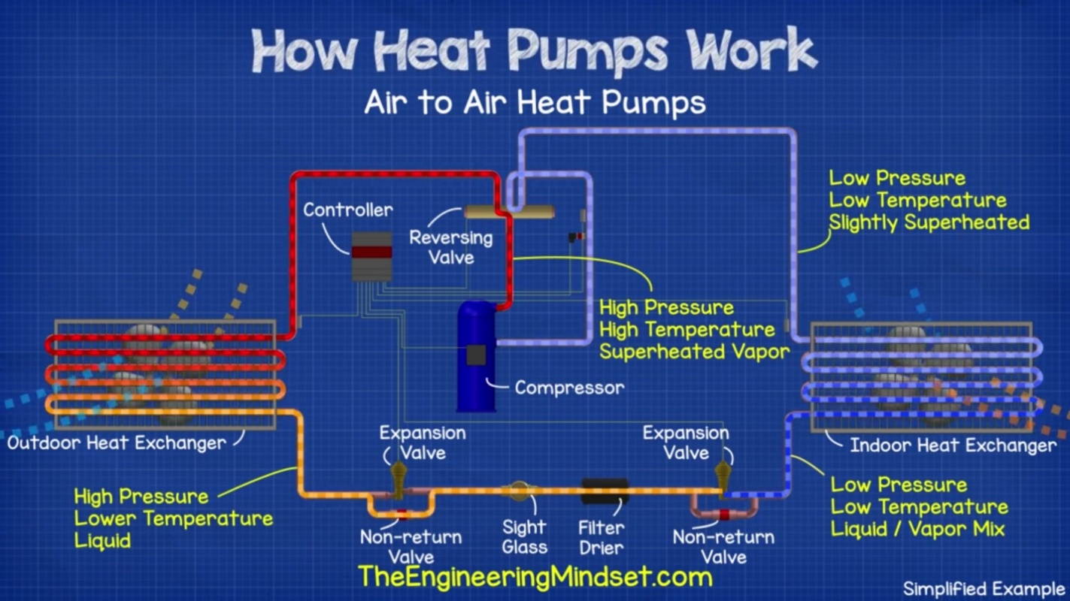

Figure no. 7.2: Heat Pump in Cooling mode

**Heat Pump in Heat Mode:**

Heat pumps have been used for many years in locations that typically experience milder winters. However, air-source heat pump technology has advanced, enabling these systems to be used in areas with extended periods of subfreezing temperatures.

1. A heat pump can switch from air condition mode to heat mode by reversing the refrigeration cycle, making the outside coil function as the evaporator and the indoor coil as the condenser.
2. The refrigerant flows through a closed system of refrigeration lines between the outdoor and the indoor unit.
3. Although outdoor temperatures are cold, enough heat energy is absorbed from the outside air by the condenser coil and release inside by the evaporator coil.
4. Air from the inside of your house is pulled into ductwork by a motorized fan.
5. The refrigerant is pumped from the interior coil to the exterior coil, where it absorbs the heat from the air.
6. This warmed air is then pushed through connecting ducts to air vents throughout the home, increasing the interior temperature.
7. The refrigeration cycle continues again, providing a consistent method to keep you warm.

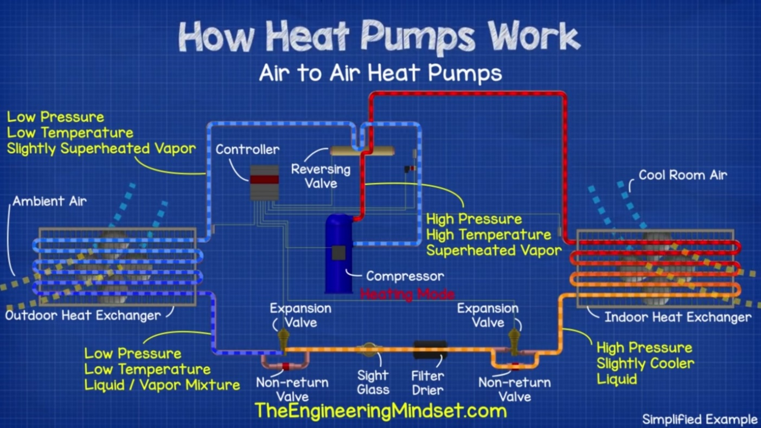

Figure no. 7.3: Heat Pump in heating mode

**Coefficient of performance:**

The measure of performance of a heat pump is also expressed in terms of the coefficient of performance COPHP, defined as

COPHP= desired output/Required input

COPHP=QH/Wnet.in

**COPHP=1/(1-QL/QH)**

It can also be expressed as:

**COPHP = COPR + 1** (for fixed values of QL and QH)

This relation implies that the coefficient of performance of a heat pump is always greater than unity since COPR is a positive quantity.

**Readings:**

**Temperature readings for winter cycle:**

|  |  |  |  |  |  |  |  |
| --- | --- | --- | --- | --- | --- | --- | --- |
| Compressor inlet | Compressor outlet | Condenser inlet | Condenser outlet | Liquid receiver | Expansion valve | Evaporator inlet | Evaporator outlet |
| 20.7 | 37.8 | 23.6 | 22.1 | 19.4 | -7.2 | -10.2 | 17 |

**Temperature readings for summer cycle:**

|  |  |  |  |  |  |  |  |
| --- | --- | --- | --- | --- | --- | --- | --- |
| Compressor inlet | Compressor outlet | Condenser inlet | Condenser outlet | Liquid receiver | Expansion valve | Evaporator inlet | Evaporator outlet |
| 17.8 | 41.5 | 25 | 21.6 | 18.5 | 4.5 | -8 | 14.1 |

**Pv , Tv and Ts diagrams:**

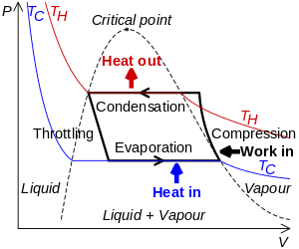

Figure no. 7.4: PV diagram of Heat pump

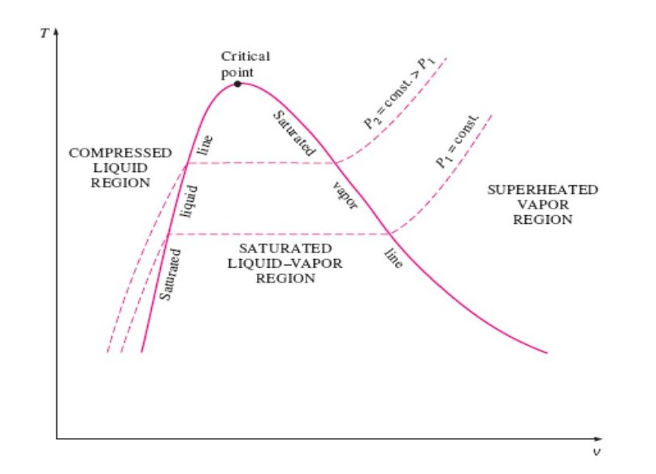

Figure no. 7.5: TV diagram of air conditioning cycle

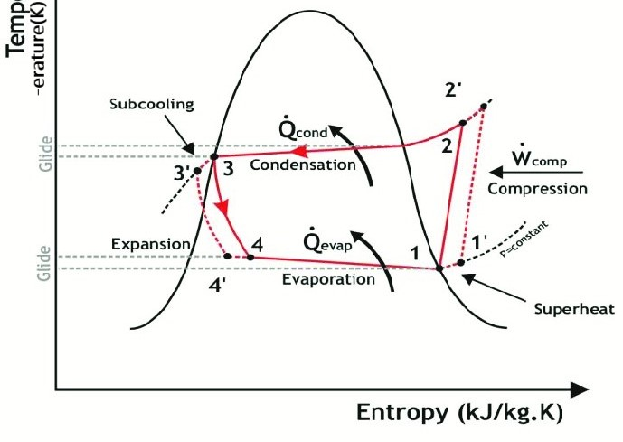

Figure no. 7.6: Ts diagram of Heat Pump

**Application:**

They are used in climates with moderate space heating and cooling needs and may also provide domestic hot water.

**Heating, ventilation, and air conditioning:**

In [heating, ventilation, and air conditioning](https://en.wikipedia.org/wiki/Heating,_ventilation,_and_air_conditioning) (HVAC) applications, a heat pump is typically a [vapor-compression refrigeration](https://en.wikipedia.org/wiki/Vapor-compression_refrigeration) device that includes a reversing valve and optimized heat exchangers so that the direction of *heat flow* (thermal energy movement) may be reversed. The reversing valve switches the direction of refrigerant through the cycle and therefore the heat pump may deliver either heating or cooling to a building. In cooler climates, the default setting of the reversing valve is heating.

**Water heating:**

In [water heating](https://en.wikipedia.org/wiki/Water_heating) applications, a heat pump may be used to heat or preheat water for swimming pools or heating potable water for use by homes and industry. Usually heat is extracted from outdoor air and transferred to an indoor water tank, another variety extracts heat from indoor air to assist in cooling the space.

**District heating:**

Heat pumps can also be used as heat supplier for [district heating](https://en.wikipedia.org/wiki/District_heating). Possible heat sources for such applications are [sewage](https://en.wikipedia.org/wiki/Sewage) water, ambient water (like sea, lake and river water), industrial [waste heat](https://en.wikipedia.org/wiki/Waste_heat), [geothermal energy](https://en.wikipedia.org/wiki/Geothermal_energy), [flue gas](https://en.wikipedia.org/wiki/Flue_gas), waste heat from [district cooling](https://en.wikipedia.org/wiki/District_cooling) and heat from [solar heat storage](https://en.wikipedia.org/wiki/Seasonal_thermal_energy_storage). Large scale heat pumps for district heating combined with [thermal energy storage](https://en.wikipedia.org/wiki/Thermal_energy_storage) offer high flexibility for the integration of variable renewable energy.